

mobile application Development

Lab 1



Muhammad daniyal qureshi

021-18-0009

BSCS_VII

# Activity 1: Image Turn on/off

# Designer:

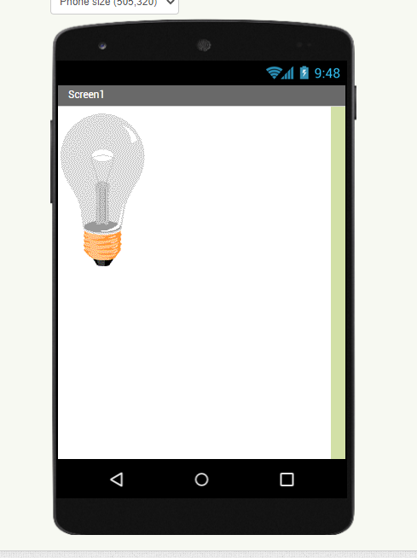

## Block

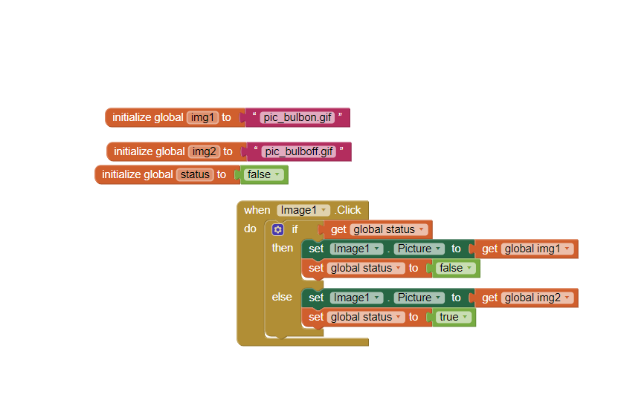

## Output

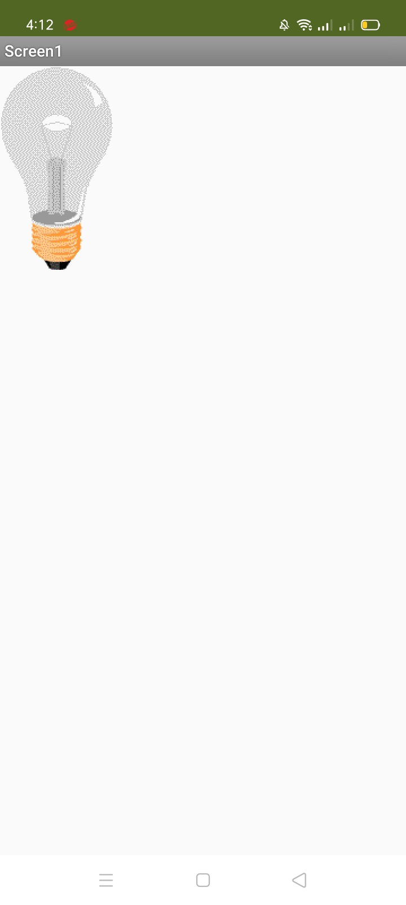

# 

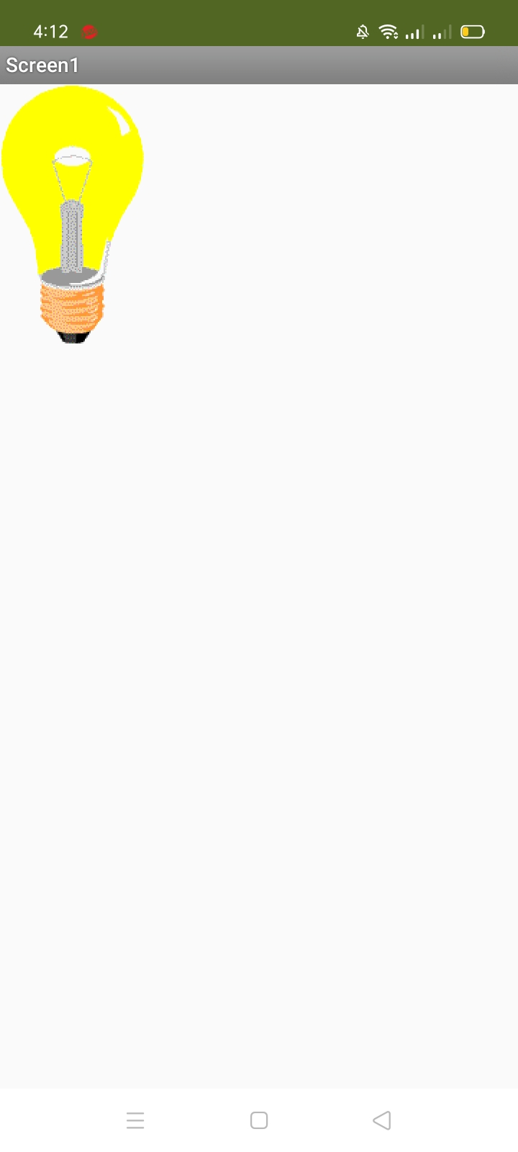

## Activity 2: Calculator

## Design:

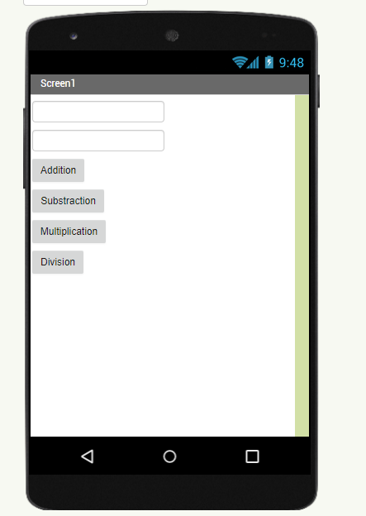

Block:

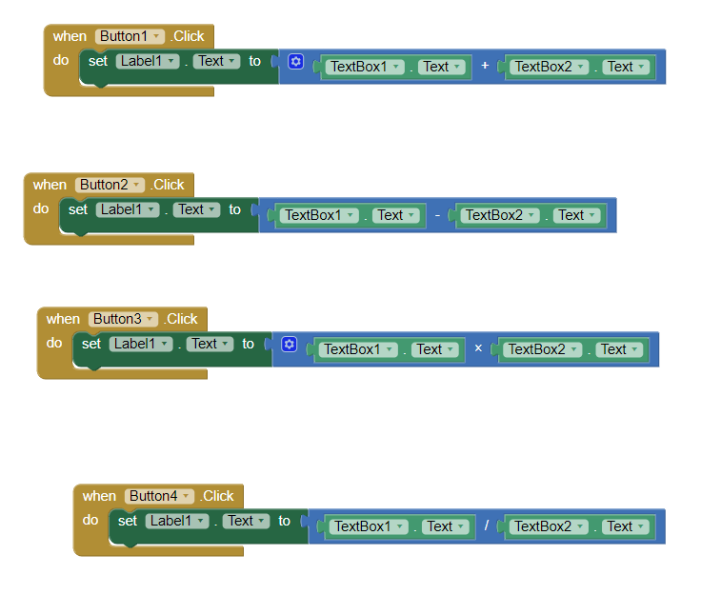

**Output**

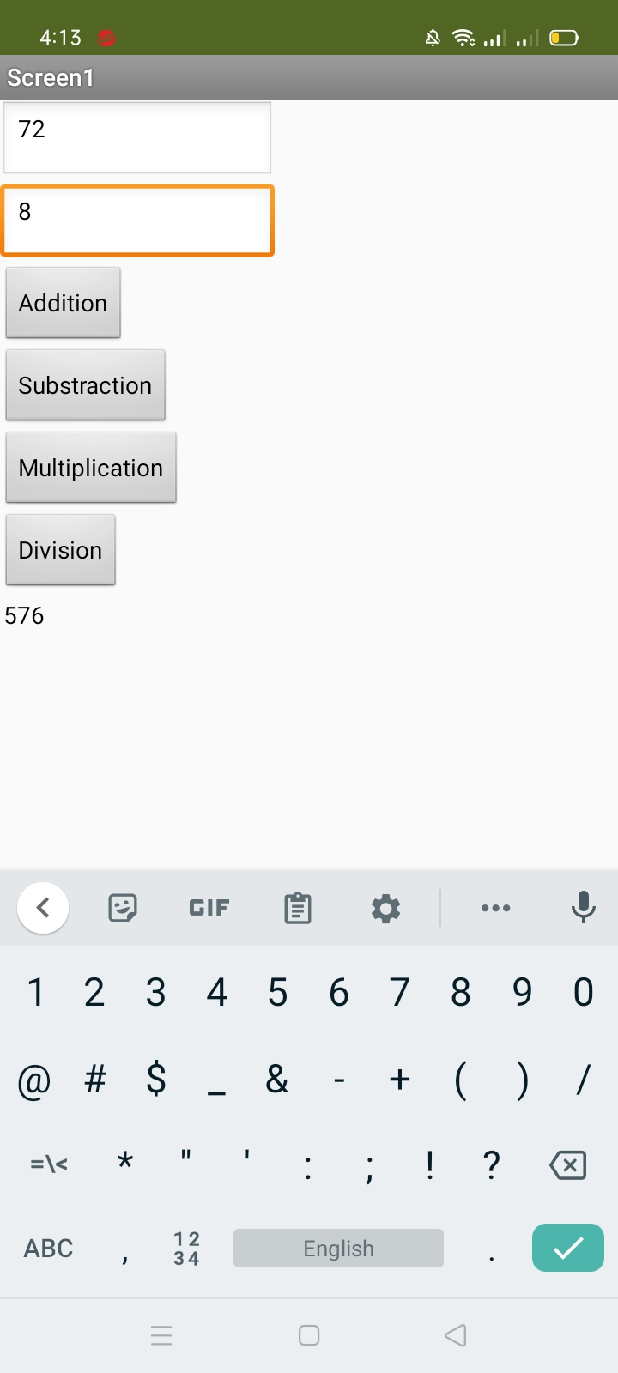

## Activity 3: Sending SMS

## C:\Users\Daniyal\AppData\Local\Microsoft\Windows\INetCache\Content.Word\smsblocks.pngBlocks:

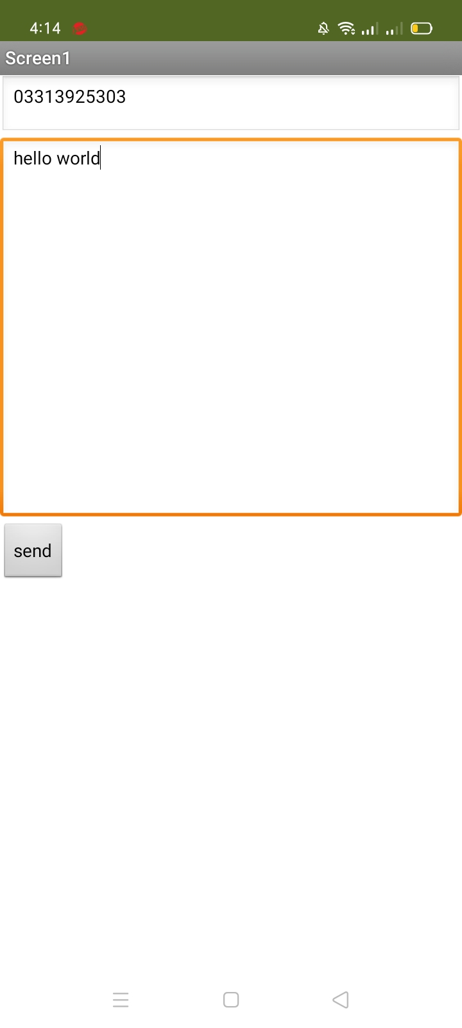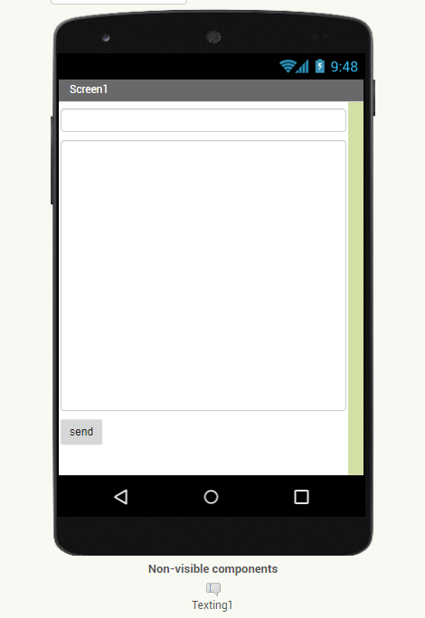

## Activity 4: Message Shaking

**Blocks**

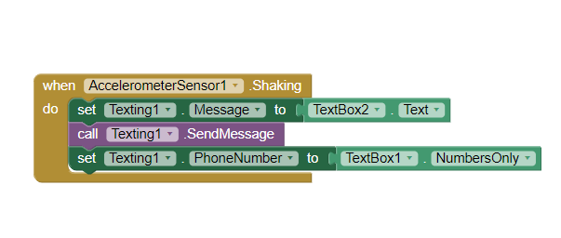

**Output**



## Activity 5:Text to Speech

**Blocks**

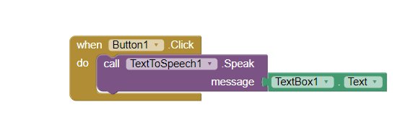

**Output**

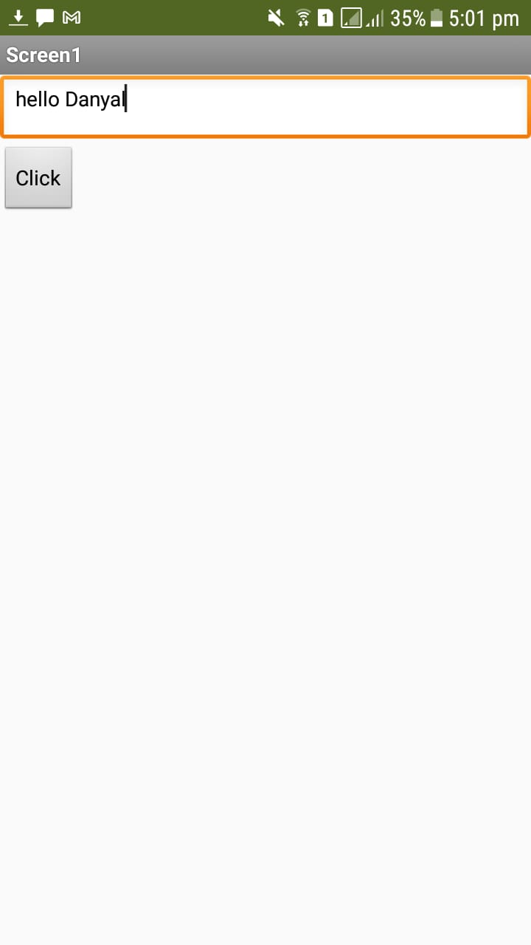

## Activity 6: Speech Recognizer

**Blocks**

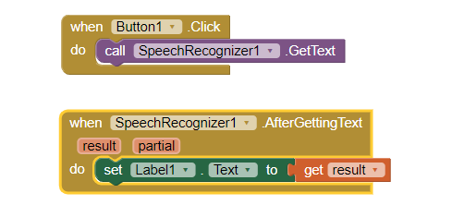

**Output**

